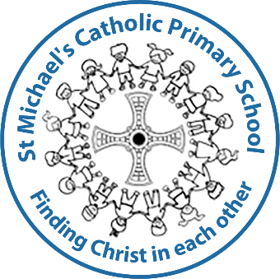
Nursery Application Form
2026-27
Child’s full name:

Date of birth: | Gender:
Home address: | Parent/carer name:
Home address: | Parent/carer phone number:
Home address: | Parent/carer email:

Name of any siblings who attend St. Michael’s:

Does your child have any medical needs we should be aware of?

Is your child ‘looked after’ or has been previously ‘looked after’ by the council? If yes, please state which council.

Does your child currently attend a nursery/childminder? Please give details below:

Please indicate how many funded hours you are entitled to:

15 hours 30 hours

For further details please refer to Get childcare: step by step - GOV.UK (www.gov.uk)

What would your preferred hours be (based on your entitlement): | Please indicate if you would be interested in paying for additional wrap around care:
30 hours Monday – Friday  15 hours Mornings only  15 hours Afternoons only  15 hours Mon am to Wed pm  15 hours Wed pm to Fri pm | Breakfast club, available 7.40-8.45am  Extended afternoon session 2.45-3.15pm  Tea Club, available 3.15-5.30pm
Please indicate when your child will be taking up their place (this will depend on your eligibility for funding (Eligibility criteria)
September 2026
January 2027
April 2027
Alternative starting dates by agreed after discussion with the headteacher.

Please note, proof of address and your child’s birth certificate must be seen prior to a place being offered. (i.e. utility bill clearly showing above address as home address).
I understand that if I am offered a Nursery place for my child this does not automatically entitle my child to a school place at St. Michael’s Catholic Primary School.

Name of parent/carer completing the form: ______________________________________
Signature: _______________________________ Date: __________________
Relationship to Child: ____________________________________________

